**SHENZHEN CHUANGTONG ELECTRONIC INSTRUMENTS CO.,LTD.**

**Declaration of Conformity UE**

**1. Massage equipment:** Rebive EX FIT (Model MT-RBEF24B/MT-RBEF24W)

**2. Name and address of the manufacturer or his authorised representative:**

SHENZHEN CHUANGTONG ELECTRONIC INSTRUMENTS CO.,LTD.

1501, Shenzhen Luohu Investment Holding Building B,112 Qingshuihe 1st Road, Luohu District, Shenzhen. GuangDong. China

**3. This declaration of conformity is issued under the sole responsibility of the manufacturer.**

**4. Object of the declaration:**

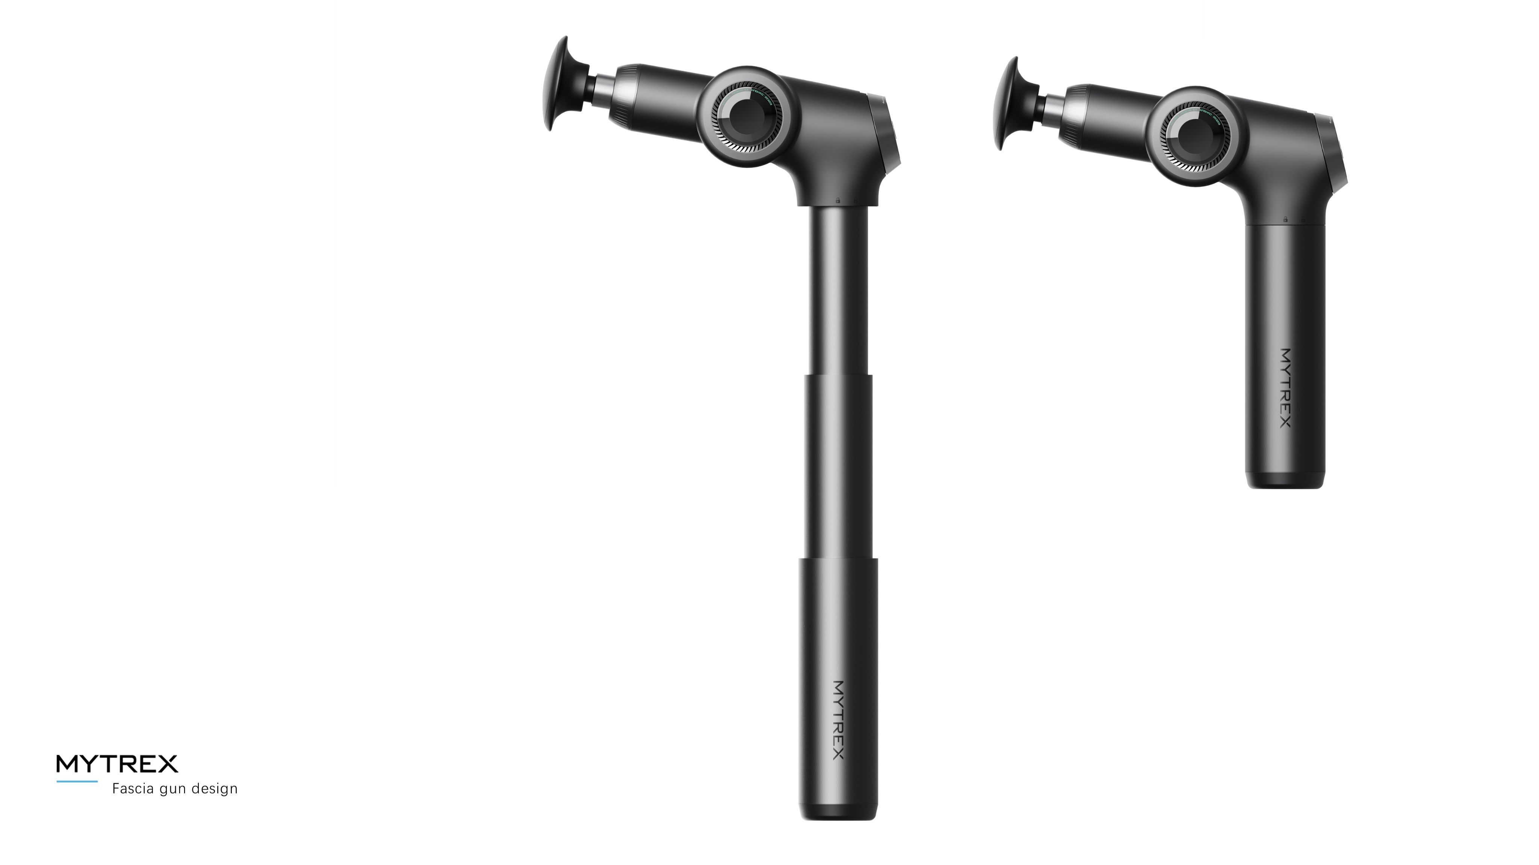

- Massager Gun with colors in black /white /Reference: MT-RBEF24B/MT-RBEF24W

**5. The subject matter of the declaration described above is in conformity with the relevant Union harmonisation legislations:**

• **EMC (2014/30/EU):** Electromagnetic Compatibility Directive

• **LVD (2014/35/EU):** Low Voltage Directive

• **RoHS (2011/65/EU):** Restriction of the use of certain hazardous substances directive

1. **References to the relevant harmonised standards used or references to the other technical specifications in relation to which conformity is declared.**

**EN IEC 55014-1:2021:** Electromagnetic compatibility - Requirements for household appliances, electric tools and similar apparatus - Part 1: Emission.

**EN IEC 55014-2:2021**: Electromagnetic compatibility - Requirements for household appliances, electric tools and similar apparatus - Part 2: Immunity

**EN IEC 60335-1:2012 + A11:2014 + A13:2017 + A1:2019 + A2:2019 + A14:2019 + A15:2021**: Household and similar electrical appliances - Safety - Part 1: General requirements + Amendment 11:2014 + Amendment 13:2017 + Amendment 1:2019 + Amendment 2:2019 + Amendment 14:2019 + Amendment 15:2021

**EN IEC 60335-2-32:2021**:Household and similar electrical appliances - Safety - Part 2-32: Particular requirements for massage appliances

**EN IEC 61000-3-2:2019 + A1:2021**: Electromagnetic compatibility (EMC) - Part 3-2: Limits - Limits for harmonic current emissions (equipment input current ≤ 16 A per phase) + Amendment 1:2021

**EN IEC 61000-3-3:2013 + A1:2019 + A2:2021**: Electromagnetic compatibility (EMC) - Part 3-3: Limits - Limitation of voltage changes, voltage fluctuations and flicker in public low-voltage supply systems, for equipment with rated current ≤ 16 A per phase and not subject to conditional connection + Amendment 1:2019 + Amendment 2:2021

**EN IEC 62233:2008**: Measurement methods for electromagnetic fields of household appliances and similar apparatus with regard to human exposure

**IEC 62321-4:2013+AMD1:2017:** Determination of certain substances in electrotechnical products. Part 4: Determination of mercury in polymers, metals and electronic components using CV-AAS, CV-AFS, ICP-OES and ICP-MS.

**IEC 62321-7-1:2015:** Determination of certain substances in electrotechnical products. Part 7-1: Determination of hexavalent chromium (Cr (VI)) in coloured and colourless corrosion protected coatings of metals by the colorimetric method.

**IEC 62321-7-2:2017:** Determination of certain substances in electrotechnical products. Part 7-2: Hexavalent chromium. Determination of hexavalent chromium (Cr (VI)) in polymers and electronic products by the colorimetric method.IEC 62321-6:2015

**IEC 62321-8:2017**: Determination of certain substances in electrotechnical products. Part 8: Phthalates in polymers by gas chromatography-mass spectrometry (GC-MS), pyrolysis/thermal desorption-gas chromatography-mass spectrometry (Py/TD-GC-MS).

**7. Additional information:**

Signed on behalf of SHENZHEN CHUANGTONG ELECTRONIC INSTRUMENTS CO.,LTD.:



**City and date:**

Shenzhen, 18th of March, 2025

**Name and position:**Zhang Liang

CEO